

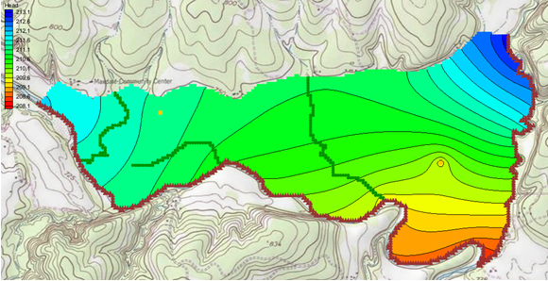

GMS 10.9

GMS 10.9 Tutorial

***MODFLOW – Conceptual Model Approach 2***

Adding drains, wells, and recharge to MODFLOW using the conceptual model approach

Objectives

The conceptual model approach involves using the GIS tools in the Map module to develop a conceptual model of the site being modeled. The location of sources/sinks, model boundaries, layer parameters (such as hydraulic conductivity), and all other data necessary for the simulation can be defined at the conceptual model level without a grid.

Time

* 15–30 minutes

Required Components

* GMS Core
* MODFLOW Interface

Prerequisite Tutorials

* Feature Objects
* MODFLOW – Grid Approach
* MODFLOW – Conceptual Model Approach 1

|  |
| --- |
| 1 Introduction 2  1.1 Getting Started 3  2 Importing the Project 3  3 Saving the Project 4  4 Delineating the Recharge Zones 4  4.1 Copying the Boundary 4  4.2 Assigning the Recharge Values 5  4.3 Mapping the Conceptual Model 5  4.4 Checking the Simulation 5  4.5 Saving and Running MODFLOW 5  5 Creating the Wells 6  5.1 Creating the Wells Coverage 6  5.2 Creating the Wells Points 6  5.3 Converting the Conceptual Model 7  5.4 Checking the Simulation 7  5.5 Saving and Running MODFLOW 7  6 Defining the Drain Arcs 8  6.1 Importing the Drain Arcs 8  6.2 Assigning the Drains 9  6.3 Converting the Conceptual Model 10  6.4 Checking the Simulation 11  6.5 Saving and Running MODFLOW 11  7 Viewing the Solutions 12  7.1 Viewing the Water Table in Side View 12  7.2 Viewing the Flow Budget 12  8 Conclusion 13 |

# Introduction

This tutorial builds on the “MODFLOW – Conceptual Model Approach 1” tutorial. In that tutorial, a one-layer model using the conceptual model approach was built. The only features assigned were the rivers, creating a simple model.

This tutorial will start with that simple model then add drains, wells, and recharge. MODFLOW will execute after each feature is added to monitor the progressive change in the model.

The problem this tutorial will be solving is illustrated in Figure 1. The site is located in eastern Texas in the United States.

This project will be modeling the groundwater flow in the valley sediments bounded by the hills to the north and the two converging rivers to the south. The boundary to the north will be a no-flow boundary and the remaining boundary will be a specified head boundary corresponding to the average stage of the rivers.

It is necessary to assume that the influx to the system is primarily through recharge due to rainfall. There are some creek beds in the area which are sometimes dry but occasionally fill up due to influx from the groundwater. These creek beds will be represented using drains. Two production wells in the area will also be included in the model.

This tutorial will discuss and demonstrate:

* Creating and defining drain arcs
* Creating and defining wells
* Add recharge values
* Converting the conceptual model to MODFLOW
* Checking the simulation and running MODFLOW
* Viewing the results



Figure Plan view of site to be modeled

## Getting Started

Do the following to get started:

1. If necessary, launch GMS.
2. If GMS is already running, select *File |* **New** to ensure that the program settings are restored to their default state.

# Importing the Project

The first step is to import the East Texas project. This will read in the MODFLOW model, the solution, and all other files associated with the model.

To import the project, do as follows:

1. Click **Open**  to bring up the *Open* dialog.
2. Select “Project Files (*.gpr)” from the *Files of type* drop-down.
3. Browse to the *modfmap2\modfmap2* directory and select “start.gpr”.
4. Click **Open** to import the project and close the *Open* dialog.
5. Select “ Rivers” to make it active.

The Graphics Window will appear as in Figure 2.

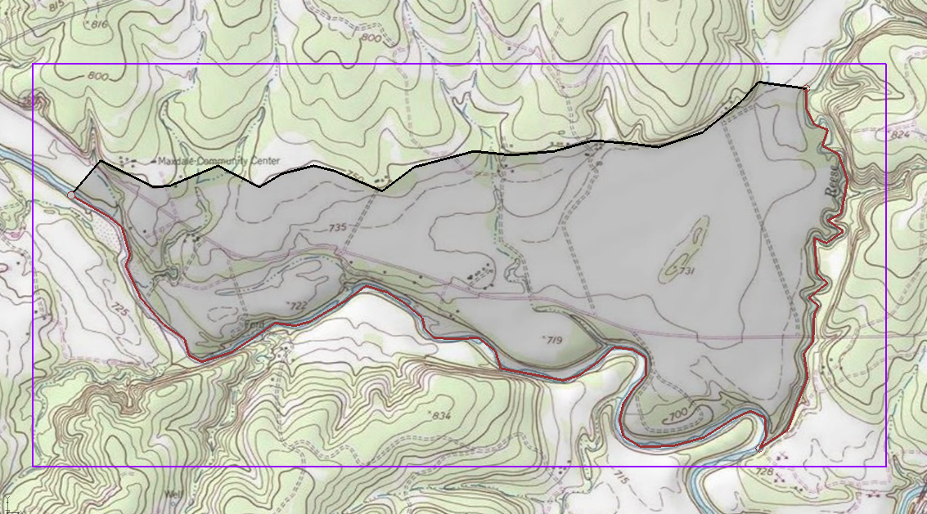

Figure The imported project

# Saving the Project

Before making any changes, save the project under a new name.

1. Select *File* | **Save As…** to bring up the *Save As* dialog.
2. Select “Project Files (*.gpr)” from the *Save as type* drop-down.
3. Enter “easttex2.gpr” for the *File name*.
4. Click **Save** to save the project under the new name and close the *Save As* dialog.

It is recommended to **Save**  periodically when working on projects, whether they are tutorials or real projects.

# Delineating the Recharge Zones

Start with constructing a coverage that defines the recharge zones. Assume that the recharge over the area being modeled is uniform.

## Copying the Boundary

To create the recharge coverage by copying the boundary coverage:

1. Right-click on the “ Boundary” coverage and select **Duplicate** to create a new “ Copy of Boundary” coverage.
2. Right-click on “ Copy of Boundary” and select **Properties…** to bring up the *Coverage Properties* dialog.
3. Enter “Recharge” as the *Coverage name* and click **OK** to close the *Coverage Properties* dialog.
4. Right-click on “ Recharge” and select **Coverage Setup…** to bring up the *Coverage Setup* dialog.

Notice that the *Coverage name* can be modified in this dialog as well.

1. In the *Areal Properties\** column, turn on *Recharge rate*.
2. Click **OK** to close the *Coverage Setup* dialog and finish defining the recharge coverage arcs.
3. Click the **Build Polygons** 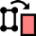maco to build the polygon on the “Recharge” coverage.

## Assigning the Recharge Values

Now that the recharge zones are defined, it is possible to assign the recharge values. This is done by assigning values to the polygon.

1. Using the **Select Polygons** 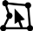 tool, double-click on the polygon to bring up the *Attribute Table* dialog.
2. Enter “0.0003” as the *Recharge rate (m/d)*.

This value was obtained by multiplying the annual rainfall by 5% and dividing by 365.

1. Click **OK** to close the *Attribute Table* dialog.

## Mapping the Conceptual Model

It is now possible to convert the conceptual model from the feature object-based definition to a grid-based MODFLOW numerical model.

1. Right-click on the “ East Texas” conceptual model and select *Map To |* **MODFLOW/MODPATH** to bring up the *Map → Model* dialog.
2. Select *All applicable coverages* and click **OK** to close the *Map → Model* dialog.
3. Turn on “ grid” in the Project Explorer.

The recharge value has now been assigned to the cells in the 3D grid.

## Checking the Simulation

At this point, the MODFLOW data is completely defined, and the simulation is now ready to be run. It is advisable to run the *Model Checker* to see if GMS can identify any mistakes that may have been made.

1. Select *MODFLOW* | **Check Simulation…** to bring up the *Model Checker* dialog.
2. Click **Run Check**. There should be no errors.
3. Click **Done** to exit the *Model Checker* dialog.

## Saving and Running MODFLOW

Save the project before running MODFLOW.

1. **Save**  the project.

Saving the project not only saves the MODFLOW files but it saves all data associated with the project including the feature objects and scatter points.

1. Select *MODFLOW |* **Run MODFLOW** to bring up the *MODFLOW* model wrapper dialog. The model run should complete quickly.
2. When MODFLOW is finished, turn on *Read solution on exit* and *Turn on contours (if not on already).*
3. Click **Close** to close the *MODFLOW* model wrapper dialog.

Contours should appear (Figure 3). These are contours of the computed recharge solution.

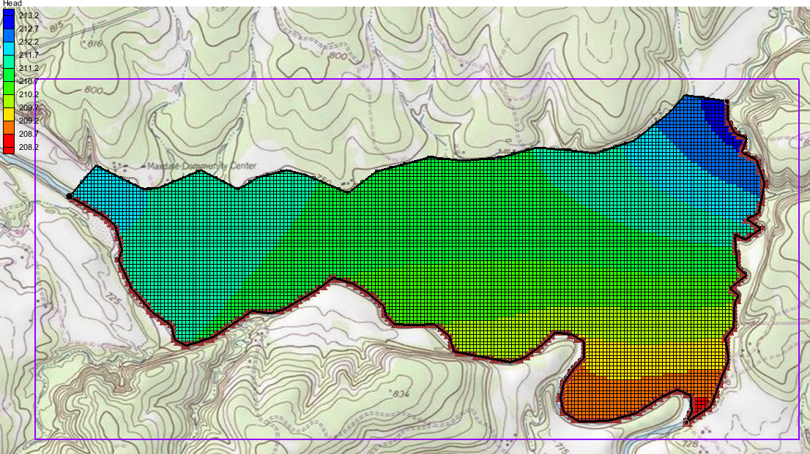

Figure The contours are visible after the MODFLOW model run

# Creating the Wells

The next step is to define the two wells. Wells are defined as point type objects.

## Creating the Wells Coverage

While the wells could be added to an existing coverage, the wells will be created on a separate coverage.

1. Right-click on the “ East Texas” conceptual model and select **New Coverage…** to bring up the *Coverage Setup* dialog.
2. Enter “Wells” for the *Coverage name*.
3. In the *Sources/Sinks/BCs* column, turn on *Wells.*
4. Click **OK** to close the *Coverage Setup* dialog.

## Creating the Wells Points

To create the two points representing the wells and assign flow value to each of them, do the following:

1. Right-click on the “ Wells” coverage and select the **Attribute Table…** command to up the *Attribute Table* dialog.
2. Turn on *Show coordinates*.
3. Under *Name*, enter “Well 1” then press *Tab*.
4. Enter the coordinates “613250.0” for *X,* “3428630.0” for *Y,* and “213.0” for *Z* pressing the *Tab* key after each.
5. Select “well” from the drop-down in the *Type* column.
6. Enter “-50.0” in the *Flow rate (m^3/d)* column.
7. Change the *BC type* drop-down menu to “ANY/NONE”.
8. On the next row down, repeat steps 3–6, entering “Well 2” for the *Name*,“615494.0” for *X*, “3428232.0” for *Y,* “213.0” for *Z*, and “-300.0” for the *Flow rate (m^3/d)*.
9. Click **OK** to close the *Attribute Table* dialog.

The location of the wells should be as seen in Figure 4.

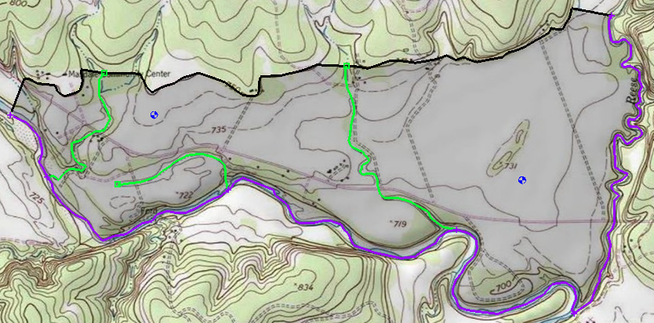

Well #1

Well #2

Figure Location of the wells

## Converting the Conceptual Model

Now add the wells to the MODFLOW numerical model.

1. Right-click on the “ East Texas” conceptual model and select *Map To |* **MODFLOW/MODPATH** to bring up the *Map → Model* dialog.
2. Select *All applicable coverages* and click **OK** to close the *Map → Model* dialog.

The wells have now been added to the grid.

## Checking the Simulation

Check the simulation before running MODFLOW.

1. Select *MODFLOW* | **Check Simulation…** to bring up the *Model Checker* dialog.
2. Click **Run Check**. There should be no errors.
3. Click **Done** to exit the *Model Checker* dialog.

## Saving and Running MODFLOW

Save the project before running MODFLOW.

1. **Save**  the project.
2. Select *MODFLOW |* **Run MODFLOW** to bring up the *MODFLOW* model wrapper dialog. The model run should complete quickly.
3. When MODFLOW is finished, turn on *Read solution on exit* and *Turn on contours (if not on already).*
4. Click **Close** to close the *MODFLOW* model wrapper dialog.

Contours should appear (Figure 5). These are contours of the computed head solution.

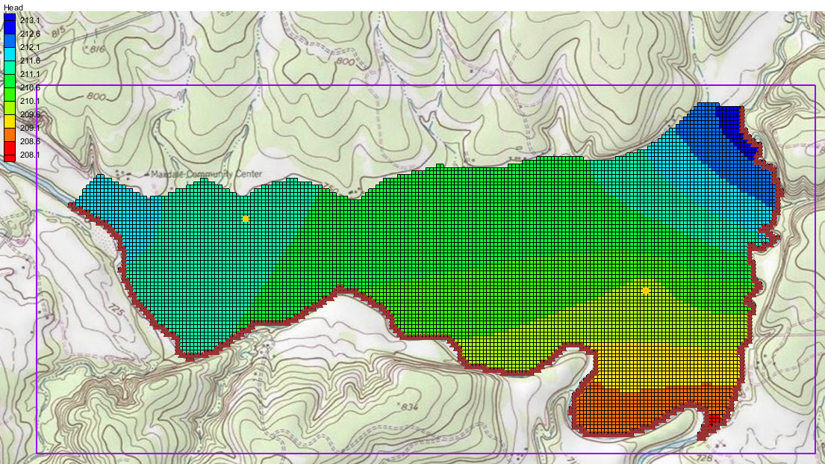

Figure The MODFLOW model run, including the wells

# Defining the Drain Arcs

Start with adding arcs at the locations of the creek beds to define the drains. The arcs could be creating using the **Create Arc** tool. In this case, the drain arcs will be imported from a map file and added to the conceptual model. The drain arcs will have their own map coverage which will include a boundary arc and polygon. While the drain arcs could be added to an existing coverage, having the arcs on a separate coverage makes it easier to define the drains.

## Importing the Drain Arcs

To import the drain arcs, do the following:

1. Click **Open**  to bring up the *Open* dialog.
2. Select “Map Files (*.map)” from the *Files of type* drop-down.
3. Browse to the *modfmap2\modfmap2* directory and select “Drains.map”.
4. Click **Open** to import the project file and close the *Open* dialog.

GMS imports the drain arcs on their own coverage in a separate conceptual model. The arcs will appear in the Graphics Window as shown in Figure 6.

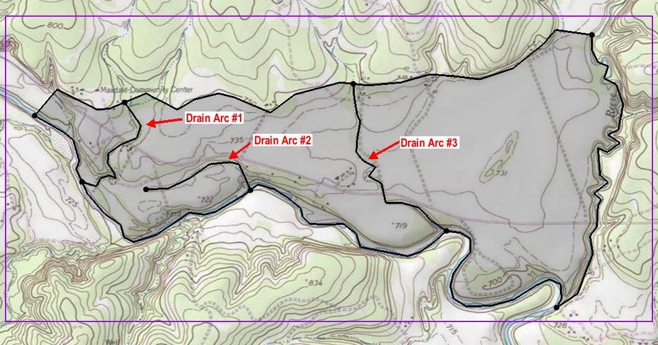

Figure Drain arcs

The drain arcs need to be added to the “ East Texas” conceptual model.

1. Select the “ Drains” coverage under the “ Drains Arcs” conceptual model.
2. Drag the “ Drains” coverage to be under the “ East Texas” conceptual model.
3. Click **Yes** on the warning dialog.
4. Right-click on the “ Drains Arcs” conceptual model and select **Delete**.

## Assigning the Drains

Next to define the arcs as drains and assign the conductance and elevation to the arcs.

1. Select the “ Drains” coverage to make it active.
2. Using the **Select Arcs**  tool and while holding down the *Shift* key, select all three drain arcs.
3. Right-click on one of the selected arcs and select **Attribute Table…** to bring up the *Attribute Table* dialog.
4. In the *All* row, select “drain” from the drop-down in the *Type* column.
5. In the *All* row, enter “555.0” in the *Cond. (m2/d)/(m)* column.

Conductance is calculated using the following formula:



Where *k* is the hydraulic conductivity, *A* is the gross cross-sectional area, and *L* is the flow length. In this tutorial, assume that the hydraulic conductivity is 12 m/day, the drain width is 9.25 m, and the flow length is 0.2 m. This will give a conductance of 555 (m2/day)/(m).

This represents a conductance per unit length value. GMS automatically computes the appropriate cell conductance value when the drains are assigned to the grid cells.

1. Click **OK** to close the *Attribute Table* dialog.

The color of the drain arcs should change to show they are now recognized as drains by GMS.

The elevations of the drains are specified at the nodes of the arcs. The elevation is assumed to vary linearly along the arcs between the specified values.

1. Using the **Select Points/Nodes**  tool, double-click on Node 1 as shown in Figure 7 to bring up the *Attribute Table* dialog.
2. On the *drain* row, enter “221” in the *Bot. elev. (m)* column.
3. Click **OK** to close the *Attribute Table* dialog.
4. Repeat steps 7–9 to assign the drain elevations from the list below to the rest of the nodes shown in Figure 7.

|  |  |
| --- | --- |
| Node 1: 221.0 | Node 4: 211.0 |
| Node 2: 212.0 | Node 5: 221.0 |
| Node 3: 220.0 | Node 6: 210.0 |

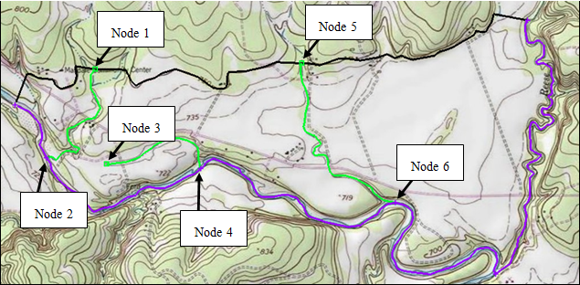

Figure Locations of the drain nodes

## Converting the Conceptual Model

To add the arcs to the MODFLOW numerical model.

1. Right-click on the “ East Texas” conceptual model and select *Map To |* **MODFLOW/MODPATH** to bring up the *Map → Model* dialog.
2. Select *All applicable coverages* and click **OK** to close the *Map → Model* dialog. The Graphics Window should appear as in Figure 8.

Notice that the cells underlying the drains were all identified and assigned the appropriate sources/sinks. The heads and elevations of the cells were determined by linearly interpolating along the general head and drain arcs. The conductances of the drain cells were determined by computing the length of the drain arc overlapped by each cell and multiplying that length by the conductance value assigned to the arc.

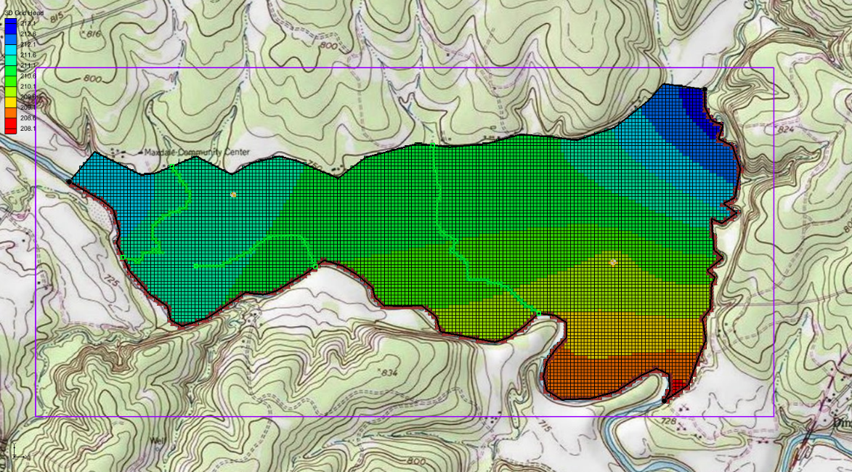

Figure After the conceptual model is converted to MODFLOW

## Checking the Simulation

Check the simulation before running MODFLOW.

1. Select *MODFLOW* | **Check Simulation…** to bring up the *Model Checker* dialog.
2. Click **Run Check**. There should be no errors.
3. Click **Done** to exit the *Model Checker* dialog.

## Saving and Running MODFLOW

Save the project before running MODFLOW.

1. **Save**  the project.
2. Select *MODFLOW |* **Run MODFLOW** to bring up the *MODFLOW* model wrapper dialog. The model run should complete quickly.
3. When MODFLOW is finished, turn on *Read solution on exit* and *Turn on contours (if not on already).*
4. Click **Close** to close the *MODFLOW* model wrapper dialog.

Contours should appear (Figure 9). These are contours of the computed head solution.

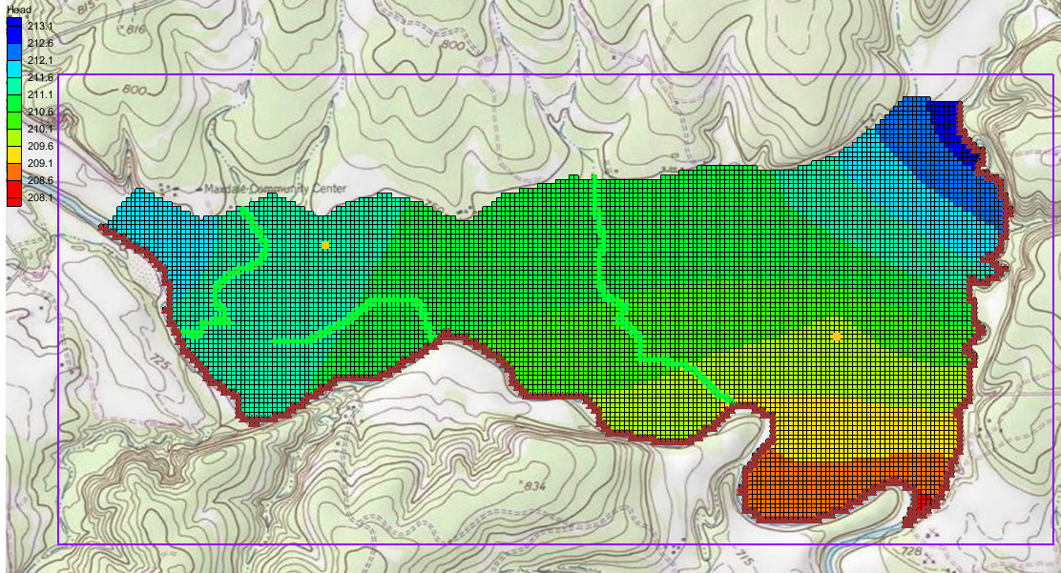

Figure The MODFLOW model run including drains

# Viewing the Solutions

## Viewing the Water Table in Side View

Another interesting way to view a solution is in side view.

1. Turn off “ Grid Frame” in the Project Explorer.
2. Select “ MODFLOW” in the Project Explorer to switch to the 3D Grid module.
3. Using the **Select Cell** tool, select a cell somewhere near the well on the right side of the model.
4. Switch to **Side View** .
5. Click **Frame Image** .

Notice that the computed head values are used to plot a water table profile.

1. Use the arrow buttons  in the main toolbar to move back and forth through the grid. A cone of depression should be seen at the well.
2. When finished, switch to **Plan View** .

## Viewing the Flow Budget

The MODFLOW solution consists of both a head file and a cell-by-cell flow (CCF) file. GMS can use the CCF file to display flow budget values. To know if any water exited from the drains, simply click on a drain arc.

1. Expand the “ Map Data” folder in the Project Explorer*.*
2. Select the “ Drains” coverage to make it active.
3. Using the **Select Arcs**  tool, select the rightmost drain arc.

Notice that the total flow through the arc is displayed in the strip at the bottom left of the window. Next, view the flow to the river.

1. Select the “ Rivers” coverage to make it active.
2. Click on one of the specified head arcs at the bottom and view the flow.
3. Hold down the *Shift* key and select all of the specified head arcs.

Notice that the total flow is shown for all selected arcs. Flow for a set of selected cells can be displayed as follows:

1. Select the “ 3D Grid Data” folder in the Project Explorer.
2. Select a group of cells by dragging a box around the cells.
3. Select *MODFLOW* | **Flow Budget...** to bring up the *Flow Budget* dialog.

The *Flow Budget* dialog shows a comprehensive flow budget for the selected cells.

1. Click **OK** to exit the *Flow Budget* dialog.
2. Click anywhere outside the model to unselect the cells.

# Conclusion

This concludes the “MODFLOW – Conceptual Model Approach 2” tutorial. Here are the key concepts from this tutorial:

* Feature arcs can be used to define drains in the conceptual model.
* Feature points can be used to define wells in the conceptual model.
* Feature polygons can be used to define recharge areas in the conceptual model.
* It is possible to customize the set of properties associated with points, arcs and polygons by using the *Coverage Setup* dialog.
* It is necessary to use the **Map → MODFLOW / MODPATH** command every time that conceptual model data is transferred to the grid.